DAY-4
Netflix Web-Application hosting
Step-1
- Create a folder
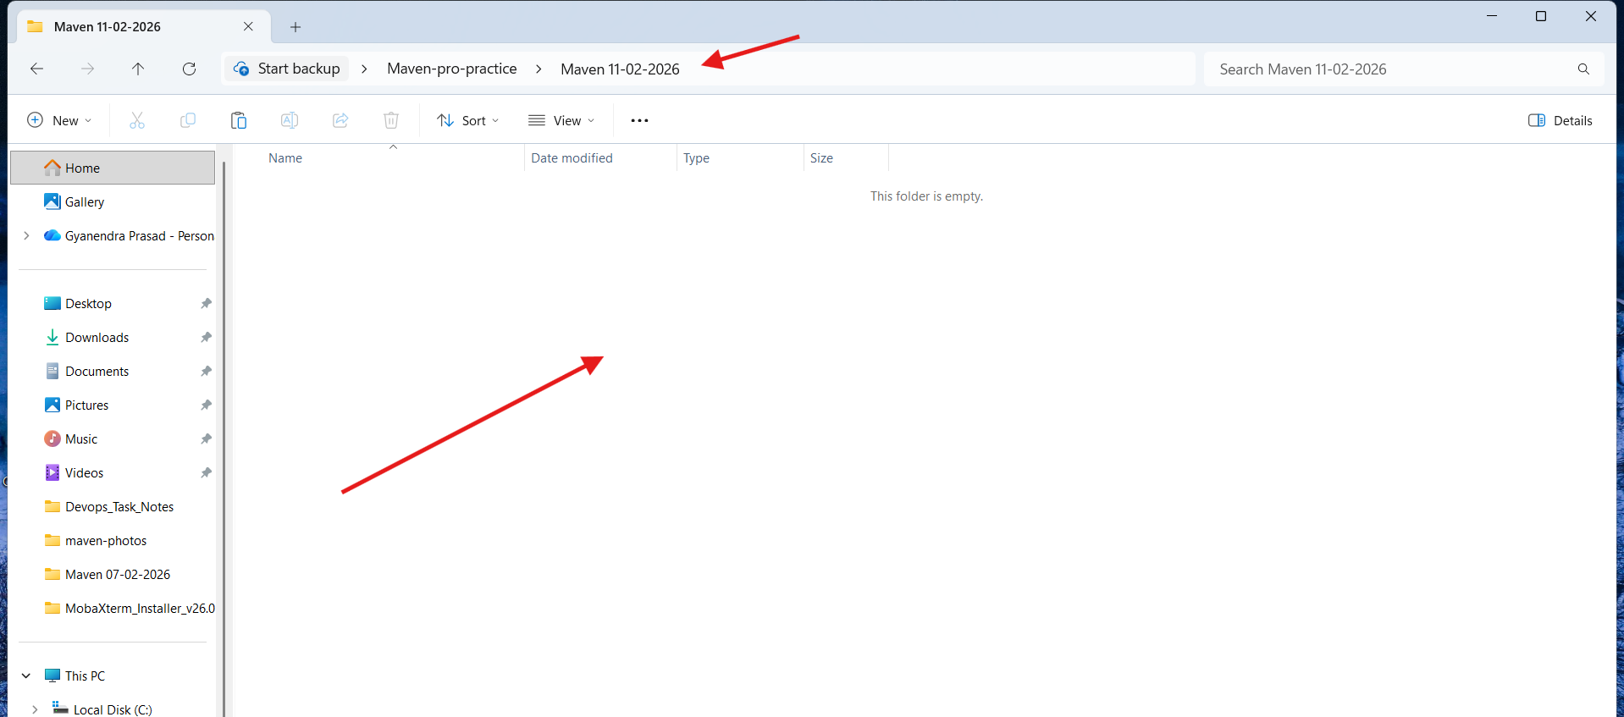
- Open that folder VS-Code.
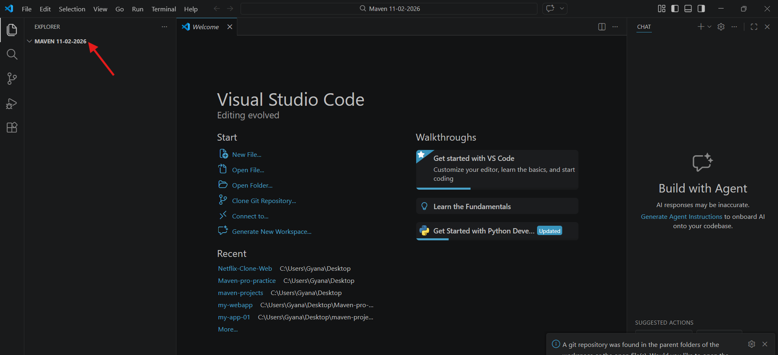
- Change the terminal from Powershell to Gitbash
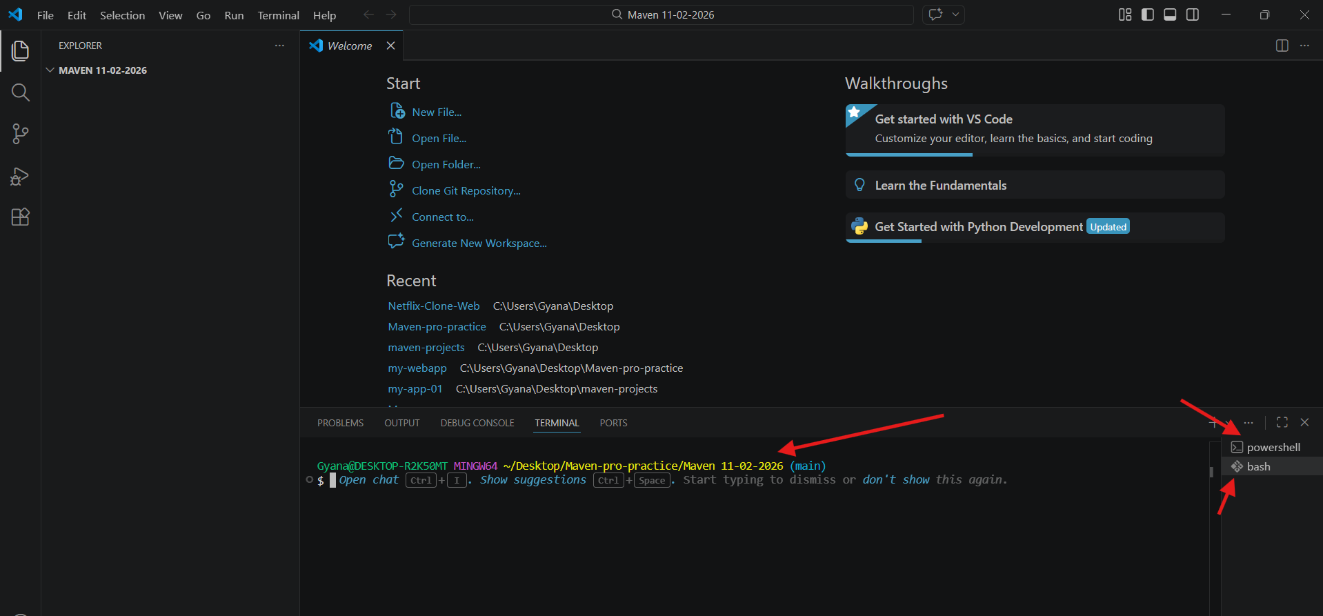
- Copy the web-app creation code and paste it there by changing the name to Netflix-Webapp.
- Syntax: mvn archetype:generate -DgroupId=com.example -DartifactId=my-webapp -DarchetypeArtifactId=maven-archetype-webapp -DarchetypeVersion=1.5 -DinteractiveMode=false

Code: mvn archetype:generate -DgroupId=com.Company -DartifactId=Netflix-webapp -DarchetypeArtifactId=maven-archetype-webapp -DarchetypeVersion=1.5 -DinteractiveMode=false
- The Netflix-webapp project structure got created.
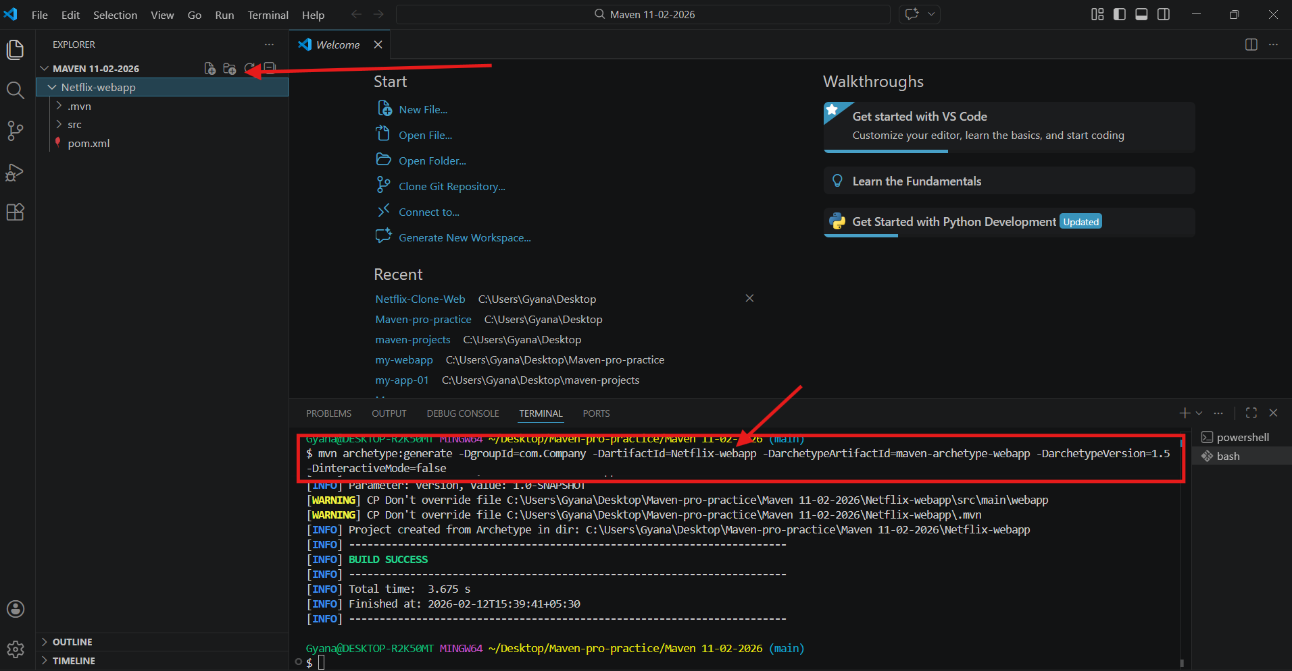

- Now paste the Netflix-clone app code in the src/main/webapp inside the index.jsp file.
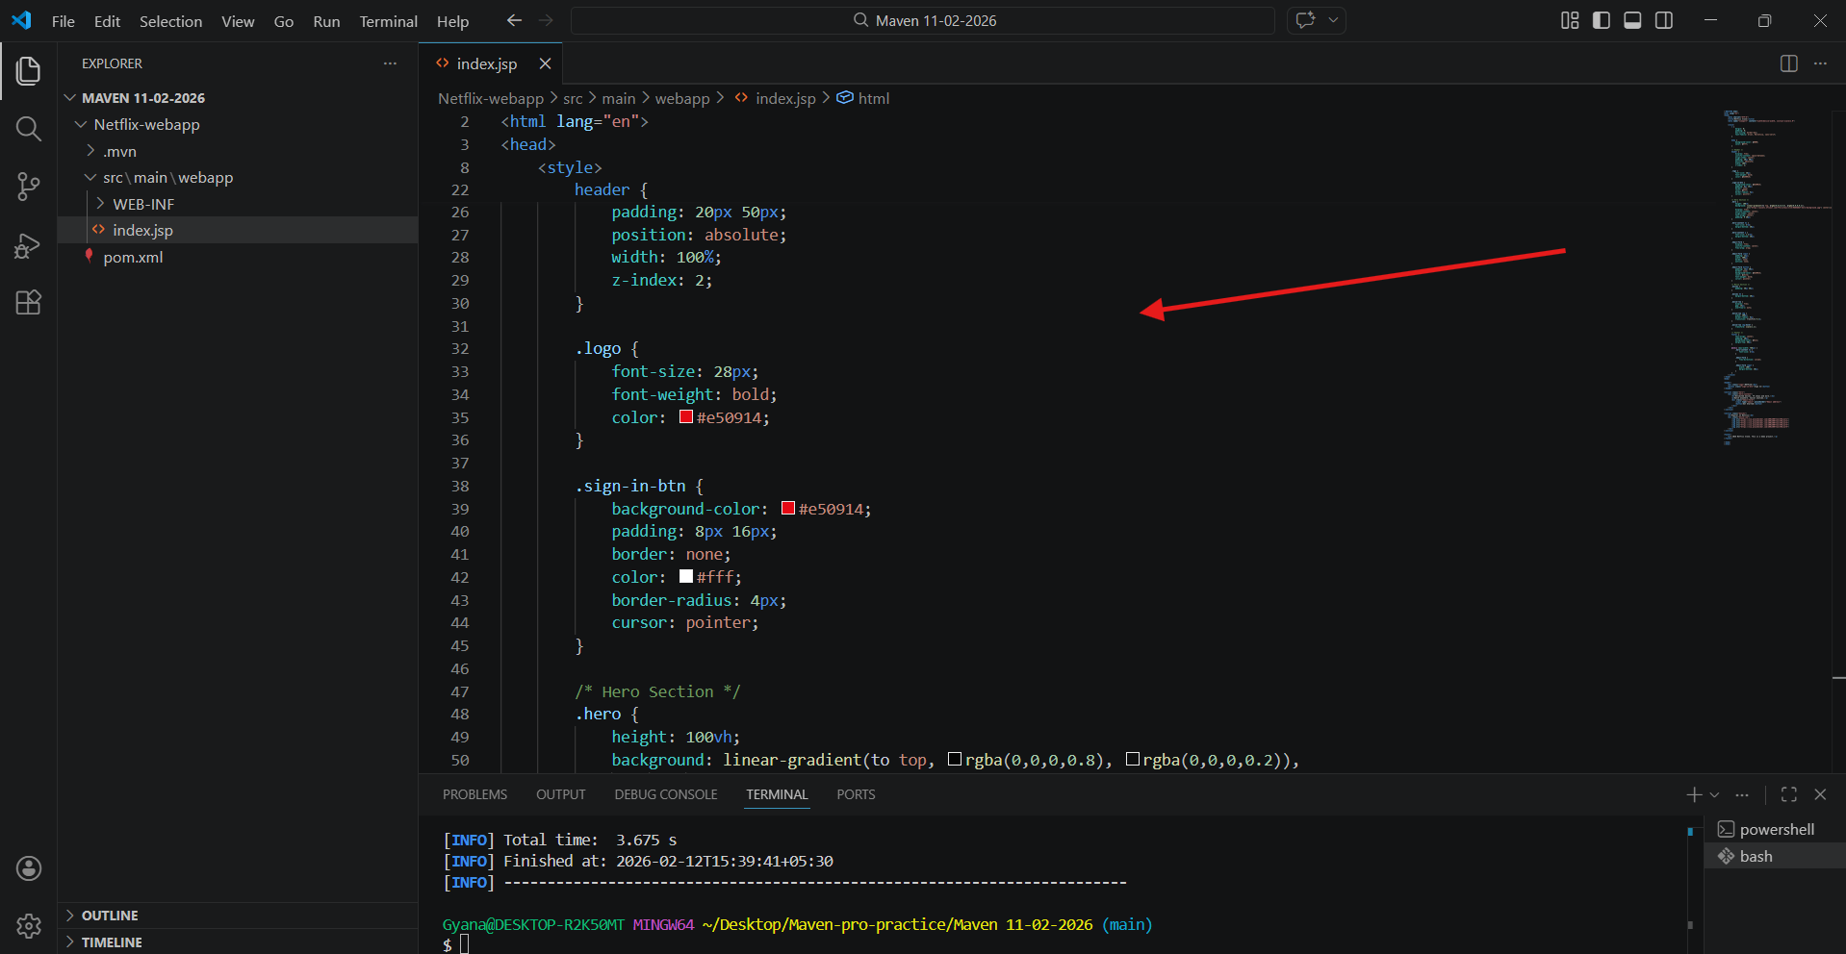
- If wants to make the changes in pom.xml file in the dependencies section can add or remove dependency.
- From the maven central repository copy the dependency and paste it here.
: https://mvnrepository.com/
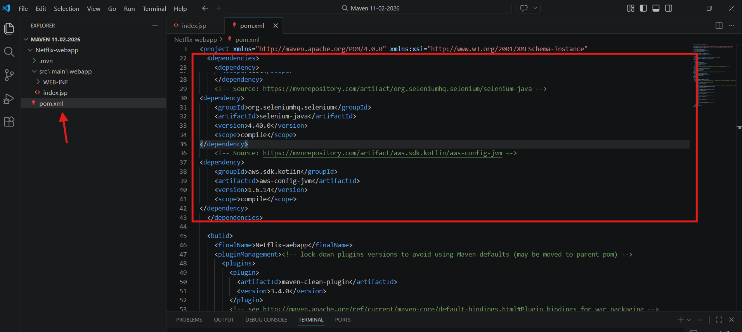

- Now change the directory to Netflix-webapp folder and run the Maven goals to execute the project.
- mvn compile: To compile the code
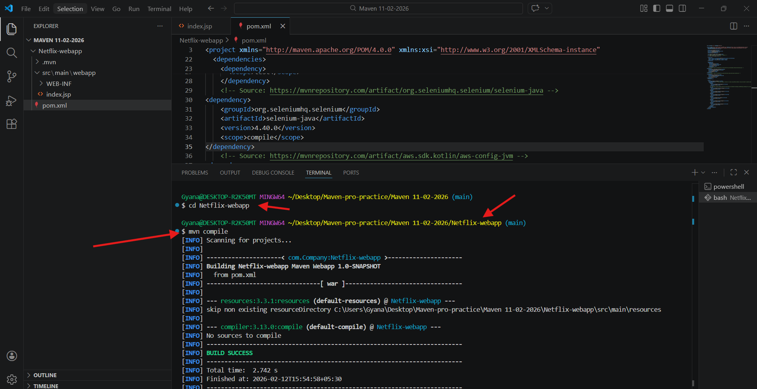
- mvn test: To test the code.
- The test get successful when it appear Build Success.
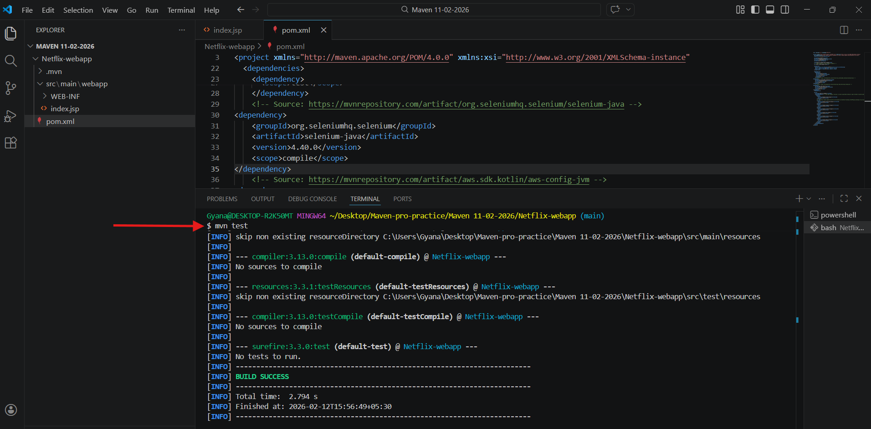

- mvn package: To package the code and it will create a Target folder which will have .war file.
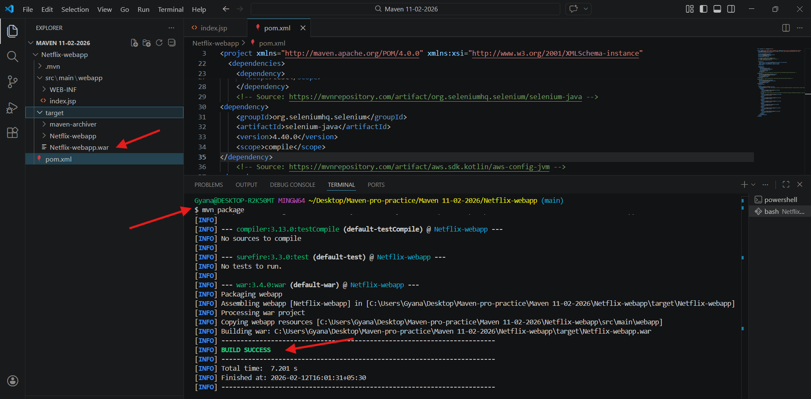
- We can execute these all commands in one line of command
- mvn clean package – This command will clean the environment and the package command will execute the compile, test and package the code at a time.
- If we run this command again then this time it will fetch the dependencies from the local repository because only first time it will fetch from the central repository.
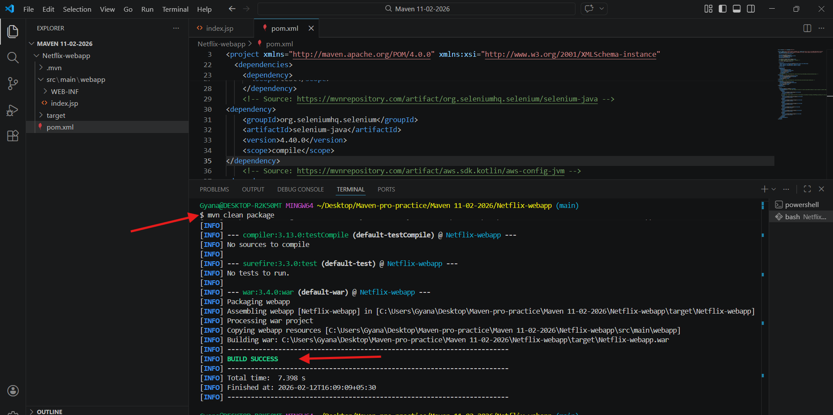

- Now copy the .war file from the target folder and paste it into the apache-tomcat’s webapp folder.
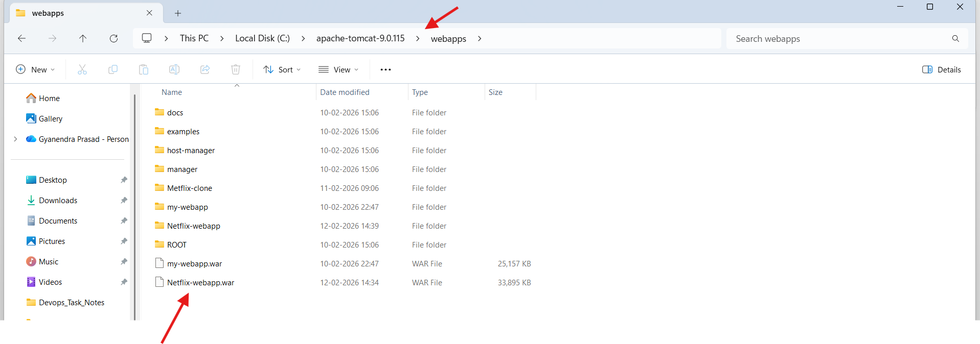
- Now open the bin folder inside the apache-tomcat folder and inside it start the tomcat server by clicking the startup windows batch file
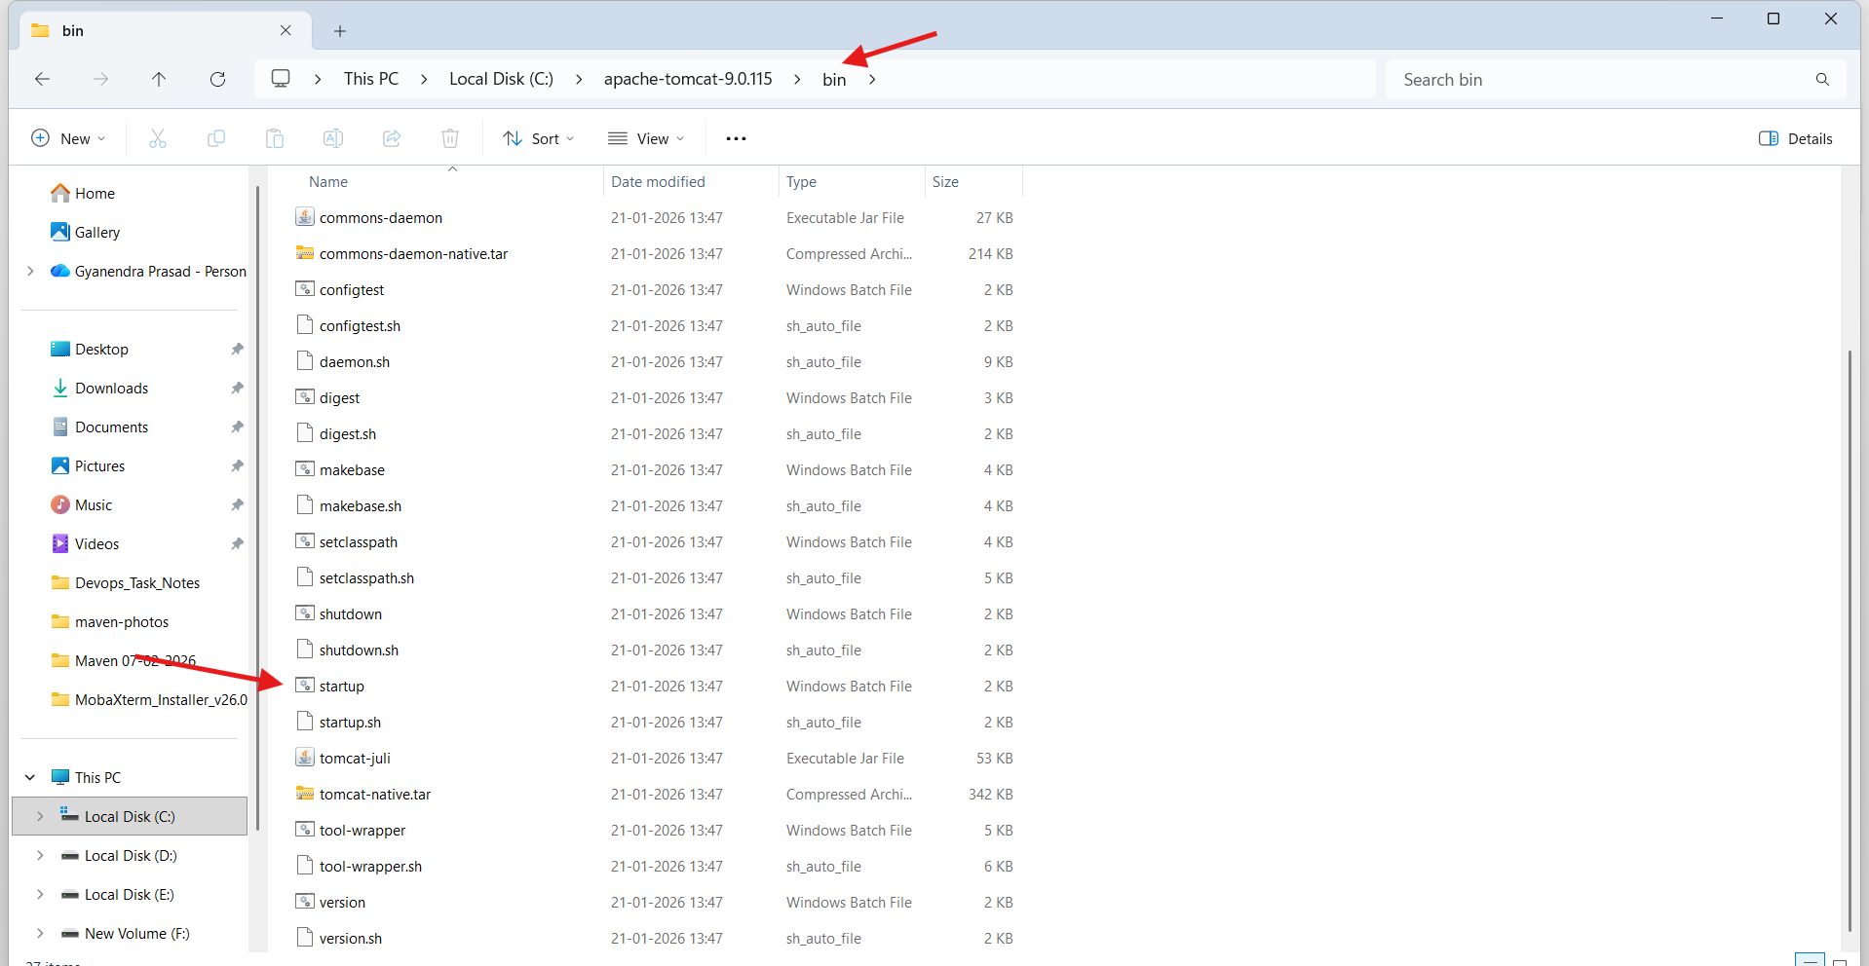
- Click on Run.
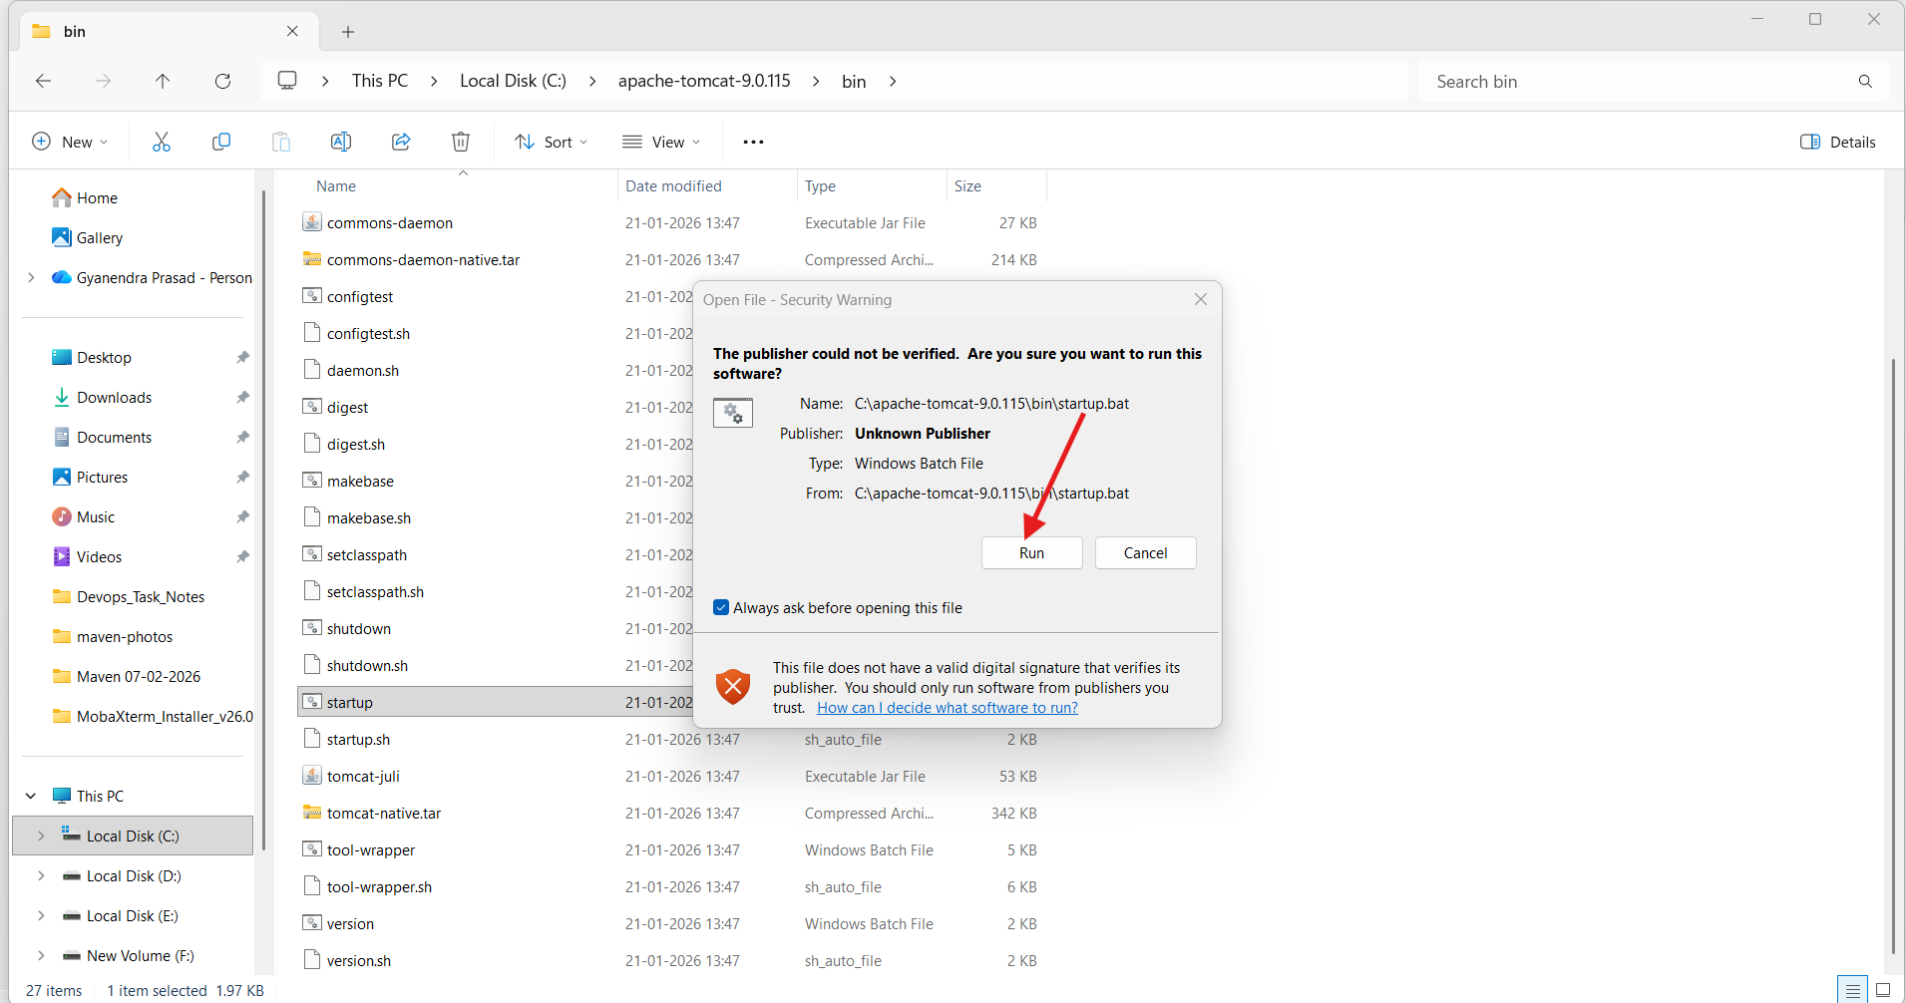
- Tomcat Server got started.
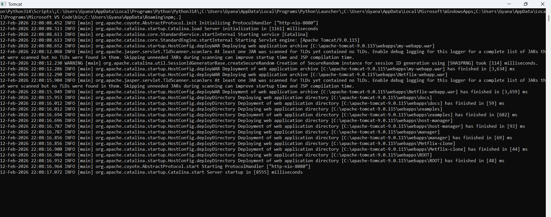

- Now search on browser: localhost:8080/Netflix-webapp to see the website.
